Management Information System
Student Name:
Institution Affiliation:
Course
Professor:
Date:

Part 1- General Business Modelling
Question 1

Threat of new entry
- Not too expensive to enter
- Some economies of scale
- No technology protection
- Low barriers to entry
- New entry quite easy:
Threat of substitution
- Some cross-product substitution
- Some substitution:
Supplier Power
- High number of suppliers
- Able to change
- Able to substitute
- High supplier power:
Buyer Power
- Homogeneous services
- Extreme price sensitivity
- Large orders
- High buyer power:
Competitive Rivalry
- Very many competitors
- Low customer loyalty
- High cost of leaving market
- Overall:

Question 2

Question 3
The location that can best fit all the demands has a latitude of 40.492909 and a longitude of -74. 443778.
The corresponding point in the google map is the Hendrich Hotel

Question 4

Business rules
- Upon check-in, present your passport, ID card or a card for temporary residence.
- Settlement of bills will be done upon presentation. Please note that personal checks will not be accepted.
- No noise within the hotel premise.
- Video or photographs taken in the hotels should be used for commercial purpose.

Question 5
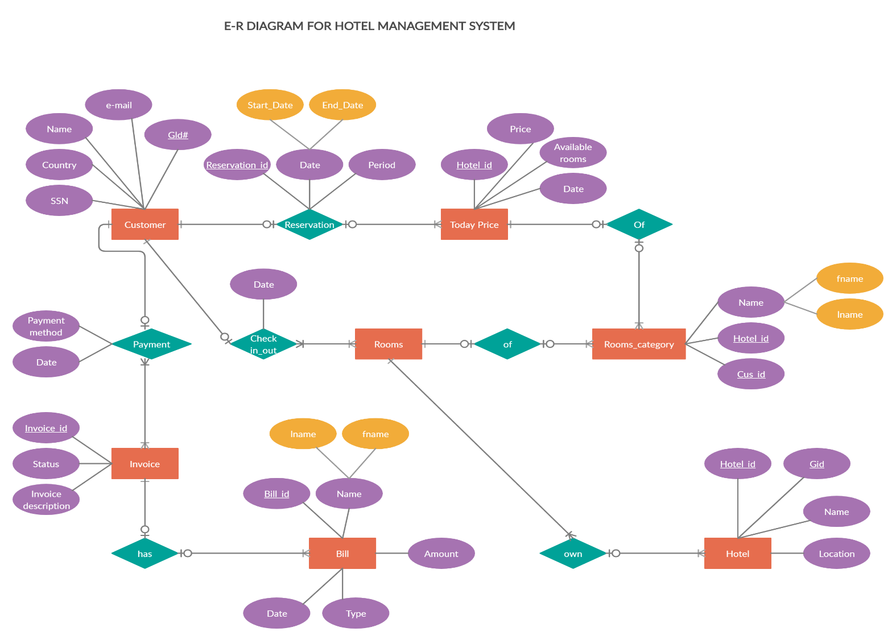
Question 6
1.
Revenue categories | April | May | June | July | August | September | Total
Room and cabin rentals | 25780 | 35149 | 71101 | 78993 | 61002 | 85797 | 357822
Excursions | 15450 | 27448 | 51320 | 55789 | 47855 | 67050 | 264912
Spa Services | 6950 | 8884 | 18010 | 20637 | 13040 | 20455 | 87976
Shop Purchases | 5200 | 9235 | 8580 | 15455 | 18355 | 17655 | 74480
Total revenue | 53380 | 80716 | 149011 | 170874 | 140252 | 190957 | 785190
Expense categories
Salaries and wages | 13345 | 20179 | 37252.75 | 42718.5 | 35063 | 47739.25 | 196297.5
Administrative | 8007 | 12107.4 | 22351.65 | 25631.1 | 21037.8 | 28643.55 | 117778.5
Marketing | 5338 | 8071.6 | 14901.1 | 17087.4 | 14025.2 | 19095.7 | 78519
Operations and Maintenance | 14946.4 | 22600.48 | 41723.08 | 47844.72 | 39270.56 | 53467.96 | 219853.2
Total Expenses | 41636.4 | 62958.48 | 116228.6 | 133281.7 | 109396.6 | 148946.46 | 612448.2
Net Income | 11743.6 | 17757.52 | 32782.42 | 37592.28 | 30855.44 | 42010.54 | 172741.8

2.

3.

4.

5.

Part 2- Business Data Management
Question 7.1
SELECT s.student_num, s.student_name, c.tuition
FROM students AS s
JOIN courses AS c
ON c.Tuition=num_credits*450

Question 7.2
SELECT s.student_num, s.student_name, e.GPA
FROM students AS s
JOIN enrolls AS e
ON e.GPA=grade<2
Question 7.3
SELECT c.department, s.female
FROM courses AS c
JOIN students AS s
ON e.female=F
ORDER BY e.female DESC, C.department;
Question 8.1
SELECT ProductName, ProductUnitPrice, UnitsinStock, ReorderLevel, UnitsinStock-ReorderLevel AS UnitStatus
FROM Products.
Question 8.2
SELECT P.TotalOrders, S.SalesRepID, S.FirstName, S.LastName
FROM Products AS P
JOIN SalesRep AS S
ON P.TotalOrders=UnitsonOrder
ORDER BY P.TotalOrders DESC;
Question 8.3
SELECT ProductName, ProductUnitPrice, UnitsOnOrder, UnitsOnOrder*ProductUnitPrice AS ValueOnOrder
FROM Products
ON ProductName=UnitsOnOrder>0
Question 8.4
SELECT ProductID,ProductName, UnitsOnOrder*ProductUnitPrice AS TotalValueOfOrders
FROM products
ON UnitsOnOrder=UnitsOnOrder>0
References
Cosenz, F., & Noto, G. (2018). A dynamic business modelling approach to design and experiment new business venture strategies. Long Range Planning, 51(1), 127-140.
Guha, S., & Kumar, S. (2018). Emergence of big data research in operations management, information systems, and healthcare: Past contributions and future roadmap. Production and Operations Management, 27(9), 1724-1735.
Pourbafrani, M., Van Zelst, S. J., & Van der Aalst, W. M. (2019, October). Scenario-based prediction of business processes using system dynamics. In OTM Confederated international conferences “On the move to Meaningful Internet Systems” (pp. 422-439). Springer, Cham.
Pozdniakov, S., Kuzmin, O., Kiiko, V., & Korenets, Y. (22018). Definition of the role of business modelling in the building of management information system.
Tilahun, M. (2019). A review on Determinants of Accounting Information System Adoption. Science Journal of Business and Management, 7(1), 17.

